3GPP TSG RAN WG1 Meeting #125 R1-2604432
Dalian, China, May. 18th ~ 22nd, 2026

Source: Pengcheng Laboratory (PCL)
Title: Discussion on ISAC evaluation for 6GR air interface
Agenda Item: 10.8.1
Document for: Discussion and Decision

Introduction
The Rel-20 study item on 6G Radio has been approved in RAN #108[1]. According to this SID, sensing capability are involved in the main objectives of 6G, as listed in the following. It is worth noting that evaluate the ISAC performance is a necessary, which is bold as follows. According to the agenda of chairman, this is the second meeting to discuss this topic related to ISAC. In this contribution, we provide our opinions and considerations on ISAC evaluation for 6GR air interface.

Note: The corresponding part is now in bold.
Objective of SI
The study aims to develop one non-backward compatible radio access technology (hereafter “6GR”) to meet a broad range of use cases, and requirements as defined during the RAN requirements study [TR38.914].
The study should strive at dimensioning an appropriate set of functionalities, minimizing the adoption of multiple options for the same functionality, focusing on practical user experience. The study should identify principles to ensure extensibility and deliver superior performance.
NOTE: Section 4.1.1 shows interim milestones to reach certain agreements, including early consensus items.
From a technology perspective, the study will address frequency ranges up to 52.6GHz, including at least the full range of FR1 (up to 7.125GHz), the range between FR1 and FR2-1 (including around ~7GHz), and FR2-1 (24.25 GHz – 52.6GHz).
NOTE: TR 38.921, TR 38.922 will be taken into account.
NOTE: Frequency ranges beyond 52.6 GHz are not in scope of the work.
The detailed objectives of the study are:
……….
(9) Sensing – Studies to be based on use cases and associated requirements, as defined in [TR38.914]
- PHY functions and procedures for sensing technology (e.g., waveform. reference signals, measurement feedback, etc…) [RAN1, RAN4]
- Evaluate sensing performance and if necessary, extend channel modelling, for the selected use cases [RAN1]
- Aspects of integration with communication services [RAN1]
- higher layer procedures and protocol aspects [RAN2]
- RAN4 aspects of sensing including RF, coexistence, and testability in coordination with other WGs [RAN4]
Note: RAN1 identify detailed requirements, if triggered by TSG RAN

NOTE: Coordination with TSG-SA and SA WGs will be done, as necessary.

In the RAN1#124bis meeting, the following agreements were reached on the 6GR ISAC Evaluation[2].
Agreement:
For Rel-20 6G sensing performance evaluation of object detection and/or tracking, the following cases/combinations are considered as baseline cases/combinations.
Sensing target | Indoor or outdoor | Scenario | Carrier frequency
UAV | Outdoor | UMa-AV, SMa | 4 GHz, ~7 GHz, 30 GHz (for UMa-AV only)
Human | Outdoor | UMa | 4 GHz, ~7 GHz, 30 GHz
 | Indoor | Indoor Hotspot | 4 GHz, ~7 GHz, 30 GHz
Vehicle | Outdoor | Urban Grid, Highway | 4 GHz, ~7 GHz, 30 GHz (for Urban Grid only)
AGV | Indoor | Indoor factory (SH) | 4 GHz, ~7 GHz, 30 GHz
- Note: sensing mode(s) for each row will be discussed
- Other cases/combinations can also be evaluated, reported and collected from companies.
Note: In this agreement, no intention to de-prioritize other scenarios or carrier frequencies.

Agreement:
Companies are encouraged to bring input to the evaluation on communication assistance in next meeting, including but not limited to:
- Necessity of evaluation on communication assistance
- For proponents, provide: what to sense and, if necessary, what/how to assist communication
  - What metric of sensing is to be defined
  - Whether/what metric related to communication is to be defined
  - Whether performance target/KPI is to be defined, for either sensing metric or communication metric
  - Necessary channel model extension
  - Necessary update of evaluation methodology on top of 5G NR sensing evaluation methodology

Agreement:
Companies are encouraged to bring input to the sensing mode related evaluation assumptions in next meeting, using the following table as starting point. The values in current table are example values based on the input and discussion in RAN1#125.
Note: This is not intended to specify all sensing modes.
Note2: This does not mean any sensing mode is applicable to any scenario/use case.
Note3: Other parameters/values for each sensing mode can also be discussed.
Sensing mode | Parameter | Value
TRP mono-static | Sensing Tx/Rx operating simultaneously or not | Simultaneously, or not simultaneously (FFS: with/without switching time and value if any)
 | BS antenna isolation | - For Around 7 GHz and below 7 GHz:  - Option 1: 80 dB  - Option 2: 65 dB  - For 30 GHz:  - Option 1: 100 dB  - Option 2: 72 dB  - Option 3: 85 dB
 | BS transmit power | - Simultaneously: min { BS transmit power in Table of ISAC system configuration, BS Rx saturation power + BS antenna isolation}, assuming the BS Rx saturation power = -28 dBm  - Not simultaneously: Follow BS transmit power in the table of general evaluation assumption
 | BS self-interference impact | The residual leakage interference/noise is modelled e.g., by additional additive white Gaussian noise, -174 + 10log₁₀(BW) + X dBm in BW Hz, BW is simulated bandwidth, X = {-Infinity, 0, 5} is up to company report.  Note: X = -Infinity corresponds to not modelling self-interference.
UE mono-static | UE type for sensing | Companies to report
 | Sensing Tx/Rx operating simultaneously or not | FFS
 | UE transmit power | FFS
 | UE Antenna isolation | FFS
 | UE Self-interference impact | FFS
 | Availability of UE location, velocity and orientation | - Option 1: Known, ideally (baseline)  - Option 2: Known, with error. FFS distribution of error in each aspect (e.g. location, speed, orientation).  - Option 3: Unknown, rely on actual measurement  Note: UE location, velocity and orientation are individually determined
TRP-TRP bi-static | Timing/frequency error | - Option 1: Ideal (baseline)  - Option 2: With error, FFS value range and model of the distribution  Note: timing error and frequency error are individually determined
 | Coherency and phase continuity among symbols within a CPI | - Option 1: Always coherent  - Option 2: Coherency is assumed under some conditions; FFS: Conditions
UE-UE bi-static | UE type for sensing | Companies to report
 | Timing/frequency error | - Option 1: Ideal (baseline)  - Option 2: With error, FFS value range and model of the distribution  Note: timing error and frequency error are individually determined
 | Availability of UE location, velocity and orientation | - Option 1: Known, ideally (baseline)  - Option 2: Known, with error. FFS distribution of error in each aspect (e.g. location, speed, orientation).  - Option 3: Unknown, rely on actual measurement  Note: UE location, velocity and orientation are individually determined
 | Coherency and phase continuity among symbols within a CPI | - Option 1: Always coherent  - Option 2: Coherency is assumed under some conditions; FFS: Conditions
TRP-UE bi-static | UE type for sensing | Companies to report
 | Timing/frequency error | - Option 1: Ideal (baseline)  - Option 2: With error, FFS value range and model of the distribution  Note: timing error and frequency error are individually determined
 | Availability of UE location, velocity and orientation | - Option 1: Known, ideally (baseline)  - Option 2: Known, with error. FFS distribution of error in each aspect (e.g. location, speed, orientation).  - Option 3: Unknown, rely on actual measurement  Note: UE location, velocity and orientation are individually determined
 | Coherency and phase continuity among symbols within a CPI | - Option 1: Always coherent  - Option 2: Coherency is assumed under some conditions; FFS: Conditions
UE-TRP bi-static | UE type for sensing | Companies to report
 | Timing/frequency error | - Option 1: Ideal (baseline)  - Option 2: With error, FFS value range and model of the distribution  Note: timing error and frequency error are individually determined
 | Availability of UE location, velocity and orientation | - Option 1: Known, ideally (baseline)  - Option 2: Known, with error. FFS distribution of error in each aspect (e.g. location, speed, orientation).  - Option 3: Unknown, rely on actual measurement  Note: UE location, velocity and orientation are individually determined
 | Coherency and phase continuity among symbols within a CPI | - Option 1: Always coherent  - Option 2: Coherency is assumed under some conditions; FFS: Conditions

In line with the Chair Notes encouraging companies to bring input on sensing mode evaluation assumptions and on communication assistance, this contribution provides our views on two key aspects: prioritization of sensing modes, and Joint Mutual Information (JMI) as a supplementary theoretical tool for system design guidance.

Prioritization of sensing modes

2.1 Analysis

2.1.1Background from RAN1#124bis
In RAN1#124bis, the following baseline cases/combinations for object detection and tracking were agreed (see Chair Notes):
Agreement:
For Rel-20 6G sensing performance evaluation of object detection and/or tracking, the following cases/combinations are considered as baseline cases/combinations.
Sensing target | Indoor or outdoor | Scenario | Carrier frequency
UAV | Outdoor | UMa-AV, SMa | 4 GHz, ~7 GHz, 30 GHz (for UMa-AV only)
Human | Outdoor | UMa | 4 GHz, ~7 GHz, 30 GHz
 | Indoor | Indoor Hotspot | 4 GHz, ~7 GHz, 30 GHz
Vehicle | Outdoor | Urban Grid, Highway | 4 GHz, ~7 GHz, 30 GHz (for Urban Grid only)
AGV | Indoor | Indoor factory (SH) | 4 GHz, ~7 GHz, 30 GHz
- Note: sensing mode(s) for each row will be discussed
- Other cases/combinations can also be evaluated, reported and collected from companies.
Note: In this agreement, no intention to de-prioritize other scenarios or carrier frequencies.

The Chair Notes also recorded the support levels for each sensing mode based on company contributions. The following table summarizes the number of companies supporting each sensing mode (sources: R1-2602521, R1-2603078):
Sensing Mode | Number of supporting companies
TRP-UE bistatic | 26
TRP mono-static | 25
UE-TRP bistatic | 23
TRP-TRP bistatic | 19
UE-UE bistatic | 12
UE mono-static | 11

2.1.2 TRP-UE bistatic sensing – highest support
TRP-UE bistatic sensing has the strongest support among all sensing modes (26 companies). Its advantages for 6G ISAC include:
- Highest consensus: Supported by more companies than any other sensing mode
- Leverages existing DL framework: TRP as transmitter and UE as receiver aligns with downlink transmission, minimizing specification impact
- Effective NLOS mitigation: In urban grid and indoor scenarios, the LOS probability between TRP and target is often low. Deploying UEs (e.g., RSUs, handheld devices) as receivers creates additional sensing paths that TRP-only sensing cannot achieve
- Spatial diversity: Multiple UEs can be deployed to provide diverse sensing perspectives, enabling cooperative sensing gains
- Feasible for Rel-20: Does not require full-duplex capability, unlike UE mono-static
It is worth noting that TRP-UE bistatic is particularly applicable to Urban Grid (vehicle), Indoor Hotspot (human), and Indoor Factory (AGV) scenarios, where NLOS conditions are common.

2.1.3 TRP mono-static sensing – complementary baseline
TRP mono-static sensing also has strong support (25 companies) and serves as an important complementary mode:
- Maturity: Extensively studied in 5G-A ISAC (TR 38.765), with well-established evaluation assumptions and simulation platforms
- Best LOS probability: Provides the highest LOS probability among all sensing modes, ideal for scenarios with clear line-of-sight (e.g., UAV sensing)
- No inter-node synchronization issues: Eliminates synchronization complexity between separate sensing nodes
- Benchmark for comparison: Serves as a reliable reference for evaluating the added value of UE-involved sensing modes

2.1.4 Other sensing modes
Other sensing modes (UE-TRP bistatic, TRP-TRP bistatic, UE-UE bistatic, UE mono-static) have lower support levels (≤23 companies) and higher implementation complexity. UE mono-static, in particular, requires full-duplex capability at the UE side, which has not been proven feasible for Rel-20 deployment and would require RAN4 input.

2.2 Proposals
Based on the above analysis, we have the following proposals:
Proposal 1: It is proposed that for Rel-20 6G ISAC evaluation, TRP-UE bistatic sensing should be prioritized as the highest priority sensing mode.

Proposal 2: It is proposed that TRP mono-static sensing should be supported as a complementary baseline.

Proposal 3: It is proposed that other sensing modes (UE-TRP bistatic, TRP-TRP bistatic, UE-UE bistatic, UE mono-static) be treated as optional for companies to report on a voluntary basis, without mandatory evaluation requirements.
NOTE: This proposal is made considering the limited remaining study timeline and the relative support levels for each mode. It does not imply that these modes lack value, but rather offers a pragmatic focus for efficient progress.

NOTE: The above prioritization does not deprecate any sensing mode identified by RAN plenary. Companies may always report results for any sensing mode they choose to evaluate.

Joint Mutual Information (JMI) as a supplementary informative metric

3.1 Consideration for performance evaluation metrics
As the recommendation ITU-R M.2160-0 [4] described, IMT-2030 is expected to provide enhanced capabilities compared to those described for IMT-2020 in Recommendation ITU-R M.2083, as well as new capabilities to support the expanded usage scenarios of IMT-2030. Integrated Sensing and Communication (ISAC) has emerged as a key technology for future wireless systems, where communication and sensing functionalities are supported using shared radio resources. In such systems, transmit power, bandwidth, waveform, and antenna configurations simultaneously affect both communication and sensing performance. Therefore, it is essential to develop appropriate performance metrics for evaluating and optimizing ISAC systems.
In existing studies, communication and sensing performances are typically evaluated using separate metrics. Communication performance is commonly measured by spectral efficiency or achievable rate, while sensing performance is evaluated using estimation-theoretic metrics such as Cramér–Rao lower bound (CRLB) or root mean square error (RMSE). Since these metrics have different physical meanings and units, it is difficult to directly compare or jointly evaluate communication and sensing performance.
As a result, current ISAC systems are often characterized using trade-off curves between communication rate and sensing accuracy. However, such trade-off analysis does not provide a unified measure of overall system performance, making it difficult to quantitatively assess the effectiveness of different system designs or resource allocation strategies.
Furthermore, the use of heterogeneous metrics also makes it challenging to perform system-level performance analysis. In particular, it is difficult to derive fundamental performance bounds for ISAC systems when communication and sensing are described using different types of metrics. Existing approaches often rely on numerical optimization to explore trade-offs, which may involve high computational complexity and may not guarantee globally optimal solutions.
In contrast, if both communication and sensing performance are expressed using information-theoretic quantities, a unified analytical framework can be established. In such a framework, sensing can be interpreted as the process of reducing uncertainty about unknown parameters, which can be quantified using entropy. The sensing performance can then be measured by the corresponding entropy reduction, i.e., sensing mutual information.
This unified representation enables the application of fundamental information-theoretic tools, such as the chain rule of mutual information, to characterize the overall information contained in the received signals. As a result, the system-level performance of ISAC systems can be more naturally analyzed, and fundamental performance bounds can be more easily derived.
Proposal 4：It is proposed to study a unified evaluation framework for Integrated Sensing and Communication (ISAC) in order to enable consistent analysis of communication and sensing functionalities within a single framework.
Observation 1: A unified ISAC performance metric is expected to satisfy the following properties:
- Consistent representation of both communication and sensing performance.
- Clear physical interpretation.
- Capability for system-level performance evaluation and comparison.
- Support for analytical characterization, including the derivation of performance bounds.

3.2 Unified ISAC performance Metrics/KPIs
As we know, conventional metrics are heterogeneous:
- Communication: spectral efficiency (bit/s/Hz), throughput (Mbps)
- Sensing: RMSE (m), CRLB, detection probability (%)
Under high mobility, Doppler shifts and fast fading affect both functionalities. A unified metric is needed to capture the fundamental information limit of ISAC systems.

3.2.1 Definition of sensing mutual information(SMI)
In sensing applications, the objective is to estimate unknown parameters of the environment, such as target location, velocity, or channel-related features. These parameters can be modeled as random variables with certain prior distributions, reflecting the uncertainty before observation. From this perspective, sensing can be interpreted as a process of reducing uncertainty about these unknown parameters based on the received signals. The uncertainty of a random parameter can be quantified using entropy. Following the definition of entropy, sensing entropy is given by:
The prior uncertainty is represented by the entropy of , while the remaining uncertainty after observation is represented by the conditional entropy given the received signal. Therefore, the sensing performance can be naturally characterized by the reduction of entropy before and after observation as:
This metric reflects the amount of information that the received signal provides about the sensing parameter and captures the overall sensing capability of the system. The above equation represents the general formula for calculating sensing performance, measured in bits. It defines the theoretical upper bound of the sensing information capacity that can be extracted from a resource block. Compared with conventional metrics such as CRLB or RMSE, the proposed metric does not depend on a specific estimator and provides a more general measure of sensing performance.

3.2.2 Unified ISAC metric-joint mutual information
In ISAC systems, the received signal contains information about both communication data and sensing parameter . Therefore, the overall system performance can be characterized using the joint mutual information:
This quantity represents the total information carried by the received signal and provides a unified measure of ISAC system capability. This decomposition provides an information-theoretic interpretation of how the received signal carries information about both communication data and sensing parameters. It should be noted that this representation is used for analytical purposes and does not necessarily imply a specific receiver structure or processing order in practical systems.
The proposed unified performance metric provides several advantages:
  - Unified evaluation: Both communication and sensing performance are measured in terms of information, enabling direct comparison and joint evaluation.
  - System-level characterization: The total system performance can be quantified using a single scalar metric, avoiding the need for trade-off curves.
  - Analytical tractability: The use of mutual information enables the application of information-theoretic tools, such as the chain rule, to analyze system behavior.
  - Performance bounds: The unified representation allows the derivation of fundamental performance limits for ISAC systems in a natural and tractable manner.
  - Design guidance: The metric can be used to evaluate the impact of system parameters (e.g., SNR, bandwidth, number of antennas, number of subcarriers) on both communication and sensing performance within a single framework.

3.2.3 System model
Consider an uplink MIMO-ISAC system, where the transmitter is communicating with the base station (BS) and BS sense the position of the transmitter. BS is equipped with a large uniform linear array (ULA), with antennas. The antennas are critically spaced with inter-antenna distance , and is the wavelength of the carrier. We establish a Cartesian coordinate system with the BS located on the y-axis, and the transmitter located on the x-y plane. We denote as the location of the transmitter, and following a uniform distribution as the prior position of the transmitter. denotes the prior space of the transmitter’s position, which can be either a line segment or a plane.

3.2.4 Sensing Mutual Information and Its Relationship with PCRLB
Under the above system model, the relationship between sensing mutual information and the posterior Cramér–Rao lower bound (PCRLB) can be established:
where denotes PCRLB matrix, and
with as the system’s confidence level for the sensing algorithm. In addition to its relationship with PCRLB, the proposed sensing mutual information metric can be further related to key system parameters in ISAC systems. Under the considered model, the sensing mutual information can be expressed as a function of system parameters such as signal-to-noise ratio (SNR), number of subcarriers, and number of antennas:
These relationships demonstrate that the proposed metric can effectively capture the impact of key system parameters and can be used to guide ISAC system design within a unified framework.

3.2.5 Numerical Validation
To validate the analytical results, simulations are conducted under the considered system model. Fig. 1 illustrates the relationship between sensing mutual information and the number of subcarriers, together with the corresponding PCRLB performance.
Three curves are shown:
(i) sensing mutual information obtained via numerical integration;
(ii) sensing mutual information;
(iii) PCRLB.
It can be observed that both sensing mutual information curves increase with the number of subcarriers, indicating that increasing frequency-domain resources improves sensing performance. Moreover, the analytical result closely matches the numerical integration result, which validates the accuracy of the derived expression. At the same time, the PCRLB decreases as the number of subcarriers increases, reflecting improved estimation accuracy. The opposite trends of sensing mutual information and PCRLB further confirm that the proposed metric is consistent with classical estimation-theoretic performance measures. Overall, the results demonstrate that the proposed sensing mutual information metric not only captures the impact of system parameters but also aligns well with conventional sensing performance metrics.
Fig. 1: Sensing MI and PCRLB versus the number of subcarrier under different metrics

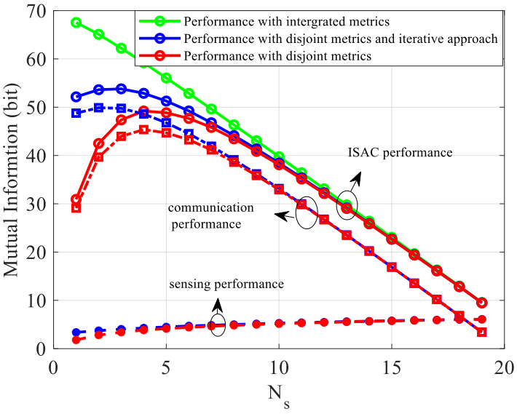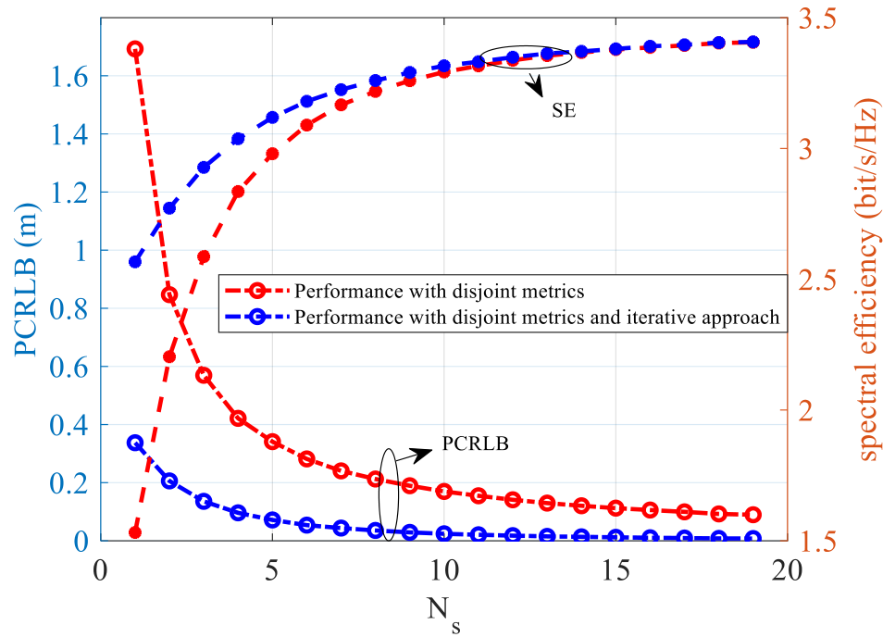
- Mutual Information Comparison (b) PCRLB and spectral effiency
Fig. 2: Performance comparison under orthogonal ISAC scheme versus the number of sensing resource blocks

Fig. 2(a) illustrates the ISAC performance versus the number of sensing resource blocks under different schemes. Three type curves are shown in the figure:
(i) the green curve represents the joint mutual information , which corresponds to the upper bound of the achievable ISAC performance under the unified information-theoretic framework;
(ii) the red curves represent the performance of a conventional separated approach, where sensing and communication are independently processed. Specifically, the total performance is obtained as the sum of the sensing mutual information (derived from PCRLB) and the communication mutual information 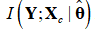;
(iii) the blue curves represent an iterative scheme, where sensing and communication mutually assist each other, i.e., the estimated sensing parameters are used to improve communication detection, and the decoded communication signals are further utilized to refine sensing performance.
It can be observed that the green curve provides a clear upper bound on the overall ISAC performance. The conventional separated approach (red curve) achieves the lowest performance due to the lack of interaction between communication and sensing. The iterative scheme (blue curve) significantly improves the performance compared to the separated approach, demonstrating the benefit of mutual assistance between communication and sensing. However, a noticeable gap still exists between the iterative scheme and the upper bound, indicating that there is still room for further performance improvement. This result highlights the importance of a unified information-theoretic framework, which not only enables the characterization of fundamental performance limits but also provides guidance for designing practical ISAC systems.
Fig. 2(b) shows the communication and sensing performance versus the number of sensing resource blocks. Two schemes are compared in the figure: the conventional separated approach (red curves) and the proposed iterative ISAC scheme (blue curves). It can be observed that the proposed scheme consistently outperforms the separated approach in both communication and sensing performance. Specifically, the blue curve achieves higher spectral efficiency while simultaneously achieving lower PCRLB compared to the red curve. This result demonstrates that, by enabling interaction between communication and sensing, it is possible to improve both functionalities simultaneously, rather than relying solely on trade-off-based designs.

3.2.6 Proposals
Based on the above analysis, we have the following proposals.
Proposal 5: It is proposed that a unified ISAC performance metric, such as Sensing Mutual Information (SMI) and joint mutual information could be used as a theoretical tool to guide system design and performance evaluation, rather than as a replacement for conventional KPIs.

Proposal 6: It is proposed that the analytical framework established in Section 3, including the relationship between SMI and PCRLB as well as the expression linking SMI to key system parameters (SNR, number of subcarriers, number of antennas), could serve as a reference for system design guidance.

Proposal 7: It is proposed that when evaluating ISAC systems, comparisons between different processing schemes (e.g., separated vs. iterative vs. unified) could be informed by analyzing how closely their achievable performance approaches the theoretical upper bound provided by JMI.

Conclusion
In this contribution, we provide our views on ISAC evaluation for 6GR air interface. According to the discussions, we have the following observation and proposals:
Proposal 1: It is proposed that for Rel-20 6G ISAC evaluation, TRP-UE bistatic sensing should be prioritized as the highest priority sensing mode.

Proposal 2: It is proposed that TRP mono-static sensing should be supported as a complementary baseline.

Proposal 3: It is proposed that other sensing modes (UE-TRP bistatic, TRP-TRP bistatic, UE-UE bistatic, UE mono-static) be treated as optional for companies to report on a voluntary basis, without mandatory evaluation requirements.
NOTE: This proposal is made considering the limited remaining study timeline and the relative support levels for each mode. It does not imply that these modes lack value, but rather offers a pragmatic focus for efficient progress.

Proposal 4：It is proposed to study a unified evaluation framework for Integrated Sensing and Communication (ISAC) in order to enable consistent analysis of communication and sensing functionalities within a single framework.

Observation 1: A unified ISAC performance metric is expected to satisfy the following properties:
- Consistent representation of both communication and sensing performance.
- Clear physical interpretation.
- Capability for system-level performance evaluation and comparison.
- Support for analytical characterization, including the derivation of performance bounds.

Proposal 5: It is proposed that a unified ISAC performance metric, such as Sensing Mutual Information (SMI) and joint mutual information could be used as a theoretical tool to guide system design and performance evaluation, rather than as a replacement for conventional KPIs.

Proposal 6: It is proposed that the analytical framework established in Section 3, including the relationship between SMI and PCRLB as well as the expression linking SMI to key system parameters (SNR, number of subcarriers, number of antennas), could serve as a reference for system design guidance.

Proposal 7: It is proposed that when evaluating ISAC systems, comparisons between different processing schemes (e.g., separated vs. iterative vs. unified) could be informed by analyzing how closely their achievable performance approaches the theoretical upper bound provided by JMI.

References
- RP-251881 New SID: Study on 6G Radio
- RAN1#124bis chair’s notes.
- R1-2602521 FL summary #4 on ISAC evaluations Moderator (CATT)

